

VELALAR COLLEGE OF ENGINEERING AND TECHNOLOGY
(Autonomous)

Approved by AICTE, affiliated to Anna University, and Accredited by NAAC with ‘A+’ Grade

DEPARTMENT OF COMPUTER SCIENCE AND ENGINEERING
(Accredited by NBA)

AN INTERNSHIP REPORT

Submitted by

ELANNGO M
(22CSR031)

in partial fulfillment of the requirements for the award of the degree of

BACHELOR OF ENGINEERING IN
COMPUTER SCIENCE AND ENGINEERING

MAY 2026



VELALAR COLLEGE OF ENGINEERING AND TECHNOLOGY
(Autonomous)

Approved by AICTE, affiliated to Anna University, and Accredited by NAAC with ‘A+’ Grade

DEPARTMENT OF COMPUTER SCIENCE AND ENGINEERING
(Accredited by NBA)

AN INTERNSHIP REPORT

Submitted by

ELANNGO M
(22CSR031)

in partial fulfillment of the requirements for the award of the degree of

BACHELOR OF ENGINEERING IN
COMPUTER SCIENCE AND ENGINEERING

MAY 2026

VELALAR COLLEGE OF ENGINEERING AND TECHNOLOGY

(An Autonomous Institution Affiliated to Anna University)

DEPARTMENT OF COMPUTER SCIENCE AND ENGINEERING

BONAFIDE CERTIFICATE

This is to certify that the Internship Report entitled “REACT NATIVE APP”, in partial fulfillment of the requirements for the award of the Degree of BACHELOR OF ENGINEERING is a record of original training undergone by ELANNGO M (22CSR031) during the period from (23.06.2025) to (01.05.2026) of her study in the department of COMPUTER SCIENCE AND ENGINEERING, VELALAR COLLEGE OF ENGINEERING AND TECHNOLOGY and the report
has not formed the basis for the award of any Degree/Fellowship or other similar title to any candidate of any University.

FACULTY IN-CHARGE | HEAD OF THE DEPARTMENT
Mrs.B.MOHANAPRIYA B.E., M.E, | Dr. S. JABEEN BEGUM, M.E., Ph.D.,
Assistant Professor, | Professor and Head,
Department of Computer Science and Engineering, | Department of Computer Science and Engineering,
Velalar College of Engineering and Technology, | Velalar College of Engineering and Technology,
Thindal, Erode-638012. | Thindal, Erode-638012.

CERTIFICATE FROM THE INDUSTRY


DECLARATION

I, ELANNGO M, hereby declare that the Internship Report, entitled “REACT NATIVE APP”, submitted to the Velalar College of Engineering and Technology in partial fulfillment of the requirements for the award of the Degree of Bachelor of Engineering is a record of original training undergone by me during the period (Jun-May 2026) and it has not formed the basis for the award of any Degree/Fellowship or other similar title to any candidate of any University.

Place: Signature of the Student

Date:

ACKNOWLEDGEMENT

On the occasion of successfully completing my internship project, I wish to express my heartfelt gratitude to the honorable Secretary and Correspondent of the Vellalar Educational Trust, Thiru. S. D. CHANDRASEKAR B.A., for providing the necessary infrastructure and support to accomplish for my internship.

I am deeply thankful to my Principal, Dr. M. JAYARAMAN Ph.D., of Velalar College of Engineering and Technology, for his continuous support and encouragement throughout my academic journey.

I would also like to express my sincere appreciation to my Dean, Prof. P. JAYACHANDAR M.E., for granting me the opportunity to undertake this internship and for his constant motivation.

My deepest gratitude goes to my Head of the Department, Dr. S. JABEEN BEGUM M.E., Ph.D., whose insightful guidance and encouragement helped me navigate through the various stages of this project.

A special thanks to my Internship Coordinator, Ms. R. DHARANI B.E., M.E., Assistant Professor, and my Internship Supervisor, Mrs. B. MOHANAPRIYA B.E., M.E., Assistant Professor, for their technical guidance, timely suggestions, and unwavering support, which were instrumental in the successful completion of my internship project.

I also wish to extend my thanks to all the teaching and non-teaching staff members of the Computer Science and Engineering Department for their assistance.

TABLE OF CONTENTS

S.NO | TITTLE |  | PAGE NO
 | BONAFIDE CERTIFICATE |  | (ii)
 | COMPANY CERTIFICATE |  | (iii)
 | DECLARATION |  | (iv)
 | ACKNOWLEDGEMENT |  | (v)
 | CONTENTS |  | (vi)
 | LIST OF FIGURES |  | (vii)
1 | ABSTRACT |  | 1
2 | INTRODUCTION ABOUT THE COMPANY |  | 2
3 | COMPANY PROFILE |  | 3
4 | INTERNSHIP OVERVIEW- WEEKLY REPORT |  | 5
 | 4.1 | DOMAIN OF TRAINING | 5
 | 4.2 | AIM & OBJECTIVES OF TRAINING | 7
 | 4.3 | SCOPE OF THE TRAINING | 8
 | 4.4 | TRAINING DETAILS | 9
5 | CONCLUSION |  | 15

LIST OF FIGURES

S.NO | FIGURE NO | CONTENTS | PAGE NO
1. | 4.1 | KEY COMPONENTS OF DATA ANALYTICS | 5
2. | 4.4 | TV CHANNEL CONTROLLER CONSOLE OUTPUT | 13

CHAPTER 1 ABSTRACT
DEVELOPMENT OF A REACT NATIVE APP
This report presents the development of a cross-platform mobile application built using React Native, designed to provide real-time factory analytics through a unified and user-friendly interface. The application focuses on delivering actionable insights such as employee attendance, customer congestion levels, and operational trends to support efficient monitoring and decision-making.

The core functionality is powered by a visual analytics pipeline that processes incoming data from multiple sources and transforms it into meaningful insights. These insights are presented through intuitive dashboards within the app, enabling users to easily interpret complex data through clear visualizations. The system emphasizes a clean and minimal UI design, ensuring a seamless and engaging user experience.

The application architecture follows a modular approach, separating data processing, analytics generation, and UI rendering to enhance scalability, maintainability, and performance. Real-time updates ensure that users always have access to the latest operational data, making the application suitable for dynamic industrial environments.

By leveraging React Native, the application supports seamless deployment across both Android and iOS platforms using native components, reducing development overhead while maintaining near-native performance. This project demonstrates effective implementation of cross-platform development, real-time data visualization, and intuitive UI/UX design for industrial analytics applications.

Keywords:
React Native, Cross-Platform Development, Factory Analytics, Attendance Tracking, Customer Congestion Analysis, Data Visualization, Mobile Dashboard, Real-Time Data, UI/UX Design, Embedded Analytics

CHAPTER 2
INTRODUCTION ABOUT THE COMPANY

BI3 TECHNOLOGIES is a forward-thinking data and analytics company dedicated to transforming raw data into meaningful insights and actionable business value. With a strong focus on innovation, scalability, and security, the company empowers organizations to harness the full potential of their data through modern cloud-based platforms and advanced analytics solutions.

At the core of BI3 TECHNOLOGIES’s operations is its comprehensive service portfolio spanning across data integration, platform engineering, and intelligent analytics. The company specializes in building real-time and IoT-driven data ecosystems, enabling businesses to gain instant visibility into operations, optimize processes, and unlock new growth opportunities. Their expertise in delivering scalable and cost-effective data platforms ensures seamless handling of large-scale data across diverse environments. BI3 TECHNOLOGIES also excels in data migration and modernization, helping organizations transition from legacy systems to modern data architectures with minimal disruption. Through managed services and continuous support, the company ensures stability, reliability, and long-term performance of data platforms.

Beyond infrastructure, BI3 TECHNOLOGIES places a strong emphasis on data intelligence. Their capabilities include defining robust data strategies, implementing governance frameworks, and ensuring high data quality and consistency through master data management practices. This enables organizations to build a trusted and unified view of their business data. On the innovation front, BI3 TECHNOLOGIES leverages cutting-edge technologies such as machine learning, artificial intelligence, and computer vision to deliver advanced analytics solutions. From predictive insights and process automation to interactive data visualizations and video analytics, the company enables data-driven decision-making across industries.

BI3 TECHNOLOGIES continues to build a reputation for delivery excellence, operational efficiency, and customer success, helping organizations transform their data into a strategic asset and maintain a competitive edge in an increasingly data-driven world.

CHAPTER 3 COMPANY PROFILE
SURESOFT SYSTEM’S PVT LTD

BI3 TECHNOLOGIES is a leading data and analytics solutions provider that delivers modern, scalable, and intelligent data-driven systems for enterprises across industries. The company specializes in transforming complex data into actionable insights through advanced analytics, cloud-based platforms, and intuitive visualization tools. BI3 focuses on enabling organizations to make informed decisions by integrating cutting-edge technologies with user-centric solutions.

Establishment:

BI3 TECHNOLOGIES has established itself as a trusted partner in the data and analytics domain, with a strong presence in delivering enterprise-grade solutions globally. Founded on the principles of unity, diversity, and collaboration, the company brings together expertise from multiple cultural and technical backgrounds to create impactful and innovative data solutions.

Key Offerings:

Data Platform Delivery: Design and implementation of scalable, secure, and cost-effective data platforms using modern cloud technologies.

• Real-Time & IoT Integration: Enabling organizations to leverage real-time data streams and IoT systems for enhanced operational visibility and optimization.

• Data Migration & Modernization: Seamless migration of legacy data systems and reporting tools to modern, efficient architectures.

• Managed Services & Operations: Continuous monitoring, maintenance, and support for data platforms ensuring reliability and performance.

• Data Strategy & Architecture: Aligning data initiatives with business goals through structured strategies and architectural frameworks.

• Data Governance & Quality Management: Ensuring data integrity, security, compliance, and consistency across enterprise systems.

• Machine Learning & AI: Leveraging advanced analytics, predictive modeling, and AI techniques to derive insights and automate decision-making.

• Data Visualization & Reporting: Development of interactive dashboards and reports for effective communication of insights.

• Process Automation: Implementation of workflow and robotic process automation to improve efficiency and reduce manual effort.

• Video Analytics: Application of computer vision and AI techniques to extract insights from video data.

Company Values:

• Data-Driven Innovation and continuous improvement

• Excellence in delivery, scalability, and performance

• Customer-Centric approach with tailored analytics solutions

• Strong focus on data security, governance, and compliance

• Collaboration through diversity and global expertise

Company Information:
- Location: No 75, 1st Floor, M Block 3rd Avenue, Anna Nagar East, Chennai – 60010,
Tamil Nadu, India.
- Contact: Ph: 044 45508333, contacts@bi3technologies.com

Specializations:

Data Engineering, Cloud Data Platforms, Data Governance, Machine Learning, AI Solutions, Data Visualization, Process Automation, IoT Analytics.

Work Culture:

BI3 TECHNOLOGIES promotes a collaborative and innovation-driven work environment where diverse teams come together to solve complex data challenges. The organization emphasizes continuous learning, knowledge sharing, and hands-on project involvement. Employees and interns work on real-world data problems, gaining exposure to modern tools, cloud platforms, and advanced analytics practices while contributing to impactful business solutions.

Technology Stack:

BI3 TECHNOLOGIES leverages a modern and flexible technology ecosystem that includes:

• Data Platforms: Snowflake, Azure Synapse, Amazon Redshift

• Visualization Tools: Power BI, Tableau, Qlik

• Programming & Analytics: Python, SQL, Machine Learning frameworks

• Automation Tools: Power Automate, RPA solutions

• AI & Video Analytics: Computer Vision, ML-based analytics

CHAPTER 4

INTERNSHIP OVERVIEW- MONTHLY REPORT

  - DOMAIN OF THE TRAINING
Data Analytics Application Development and Real-Time Visualization Systems
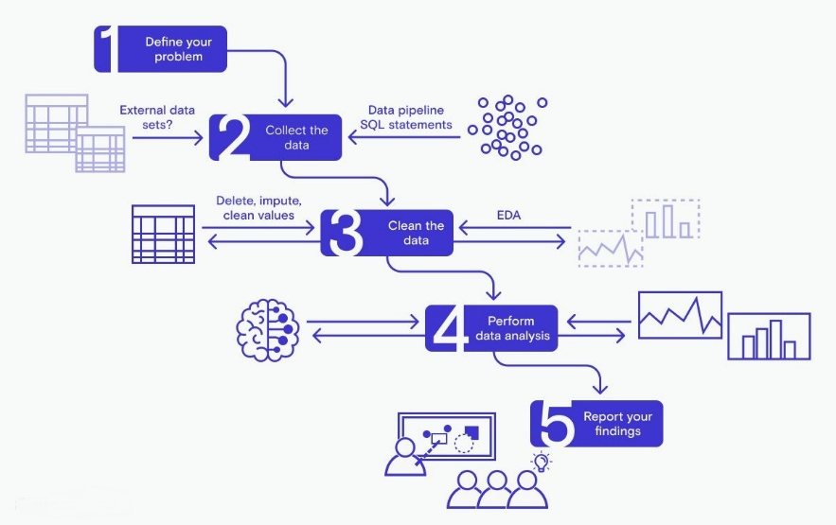
Data Analytics Application Development is a specialized domain within software engineering that focuses on transforming raw data into meaningful insights through processing, analysis, and visualization. Unlike traditional application development, this domain emphasizes handling large-scale, real-time, and heterogeneous data while ensuring scalability, performance, and usability. It is widely applicable across industries such as manufacturing, retail, healthcare, and smart infrastructure, where data-driven decision-making plays a crucial role.

FIG NO: 4.1 KEY COMPONENTS OF DATA ANALYTICS
The training domain encompasses the following core components:

Cross-Platform Mobile Application Development (React Native):
A key aspect of the training involved developing mobile applications using React Native. This enabled the creation of a single codebase that can be deployed across both Android and iOS platforms while utilizing native components for performance and user experience. I gained hands-on experience in building responsive user interfaces, managing component lifecycles, and integrating APIs to display real-time analytics in a clean and intuitive format.

Interrupt-Driven Programming:
Embedded systems often rely on interrupts to handle asynchronous events with minimal delay. I developed an in-depth understanding of how to configure and implement timer interrupts, external interrupts, and UART-based interrupts to respond to signals such as infrared (IR) input or user actions. These skills were vital for developing applications like IR signal decoders and channel controllers, where real-time response and low-latency processing are essential.

IR Signal Decoding and Protocol Implementation:

One of the key areas of focus was the decoding of IR remote signals based on standard communication protocols like NEC. This required capturing pulse durations, interpreting bit sequences, and translating them into actionable commands using timers and interrupt routines. I implemented signal mapping logic to associate decoded data with channel selection operations, gaining exposure to protocol-level communication and low-level signal processing.

Parental Lock and Access Control Systems:

I contributed to the design and implementation of a PIN-based parental lock mechanism within the channel controller project. This involved integrating secure input handling, PIN validation, and access control logic to restrict unauthorized channel access. This aspect of the training taught me the importance of user authentication in embedded applications and enhanced my ability to design layered control structures that ensure both functionality and security.

Simulation and Debugging Tools (Keil & Proteus):

Efficient debugging and simulation are critical in embedded software development. I acquired hands-on experience using Keil µVision IDE for code compilation and debugging, as well as Proteus for simulating hardware environments. These tools enabled me to validate system logic, test edge cases, and ensure that the software behaves reliably under simulated real-time conditions, reducing the gap between prototype and deployment.

UART Communication and Real-Time Monitoring:

To enable effective monitoring and debugging, I implemented UART (Universal Asynchronous Receiver-Transmitter) communication to transmit system status and logs in real-time. This skill allowed me to integrate serial communication into embedded projects, offering insights into the internal workings of the application during runtime and supporting diagnostics and evaluation.

Modular Embedded Software Design:
Throughout the internship, I followed best practices in modular programming, separating system layers into well-defined modules such as signal decoding, control logic, and user interface handling. This approach improves code readability, maintainability, and scalability—key requirements in embedded product development.

Real-Time Embedded Application Design:
The overall experience provided me with a strong foundation in real-time software design— developing responsive systems that meet timing constraints and reliably interact with hardware. I understood the intricacies of synchronizing software tasks with hardware events and developed a disciplined approach to structuring time-sensitive embedded applications.

  - AIM & OBJECTIVES OF TRAINING

To develop a modular, real-time embedded software system for decoding IR signals and controlling TV functionalities with integrated parental lock features, using only Embedded C programming.
This overarching goal was supported by several specific objectives:
- To understand and implement IR communication protocols (primarily NEC) using timer interrupts in Embedded C.
- To develop an algorithm that accurately maps remote control signals to corresponding TV channel functions.
- To integrate a secure PIN-based parental lock system for access control to restricted channels.
- To implement UART-based serial communication for debugging and user interaction.
- To organize the code in a modular architecture, separating logic for decoding, command mapping, locking, and interfacing.
- To test and verify the software functions using simulated remote input and UART feedback.
- To improve skills in embedded software design principles, including ISR handling, state machines, and layered architecture.
- To ensure the software system is robust, efficient, and adaptable for use in multi-brand Set-Top Box simulations.

  - SCOPE OF TRAINING
The scope of the software-focused embedded system project encompasses:

Technical Foundations:
      - Development in Embedded C for microcontroller-based applications.
      - Timer configuration for capturing IR pulse widths.
      - Use of interrupt service routines (ISR) for real-time signal processing.
      - Serial communication for monitoring via UART.
      - Modular programming and software layering in embedded systems.

IR Signal Processing:
      - Analysis of NEC protocol structure (start burst, space, bit encoding).
      - Capturing signal transitions using timer interrupts.
      - Implementing decoding algorithms to convert pulse widths into binary IR codes.

Channel Switching and Control Logic:
      - Mapping of decoded IR codes to functional operations (e.g., channel up/down).
      - Handling invalid or undefined codes gracefully with error messages via UART.

Parental Lock Feature:
      - Implementing a secure PIN entry system.
      - State management for enabling/disabling locked channels.
      - Handling incorrect attempts and unlocking sequences.

UART Debugging & Feedback:
      - Displaying current channel status, lock messages, and error information.
      - Using serial output as a software-based user interface.

Software Design & Architecture:
      - Layered design separating protocol decoding, feature logic, and hardware abstraction.
      - Code reusability through modular function design.
      - Proper documentation and version control practices.

Testing and Evaluation:
      - Simulation and testing of IR signal sequences.
      - Validation of lock mechanism and response times.
      - System responsiveness under different remote inputs.

Professional Development:
      - Real-time embedded development experience.
      - Exposure to consumer electronics systems and use-case driven software.
      - Collaboration and reporting through structured documentation and debugging.

  - TRAINING DETAILS
WEEK 1: SYSTEM REQUIREMENTS AND DEVELOPMENT SETUP

Overview:
The first week focused on understanding the project goals, system architecture, and setting up the embedded development environment. I was introduced to microcontroller programming fundamentals and the concept of integrating control logic with peripheral interfaces.

Key Learning Areas:
- Functional analysis of the channel controller and parental lock logic.

- Study of IR remotes and signal protocols (NEC) Familiarization with the microcontroller used (e.g., ATmega or STM32)

- Environment setup: IDEs, compilers, and simulation tools

Practical Tasks:
  - Prepared software flowcharts and logical design.

  - Installed and configured embedded toolchains and drivers.

  - Simulated remote signal reception and decoding logic.

  - Basic test programs for UART and GPIO.

Skills Developed:
  - Embedded C programming basics

  - Protocol decoding logic (IR remote)

  - Serial communication handling (UART)

  - Use of simulation and debugging tools in embedded systems.

WEEK 2: IR SIGNAL DECODING AND CHANNEL CONTROL LOGIC

Overview:
The second week was dedicated to implementing the IR signal decoding module and basic channel switching logic using microcontroller interrupt routines.

Key Learning Areas:
- Decoding NEC IR protocol

- Interrupt-driven programming in embedded systems

- Mapping IR codes to channel numbers

- State-machine-based design for remote control inputs

Practical Tasks:
  - Captured and analyzed IR signals using logic analyzer

  - Implemented ISR-based decoding for button press recognition

  - Linked decoded signals to simulated channel IDs

  - Created test routines for navigating through channels.

Skills Developed:
  - Interrupt and polling techniques

  - IR decoding and mapping logic in embedded C

  - Channel switching algorithms and system response control

WEEK 3: PARENTAL LOCK FEATURE DEVELOPMENT

Overview:

The main focus this week was developing the parental lock mechanism, enabling selective access control over specific channels based on password verification.

Key Learning Areas:
- Password input handling through remote control

- EEPROM usage for storing lock settings and passwords

- Security logic implementation (3-attempt block out)

- Menu navigation using simple on-screen displays or serial output

Practical Tasks:
  - Implemented numeric password entry via remote buttons

  - Stored and retrieved passwords using EEPROM

  - Developed channel-lock control flow and access validation

  - Simulated user-interface interaction via serial terminal.

Skills Developed:
  - Non-volatile memory handling (EEPROM)

  - Embedded security logic (password verification)

  - Implementation of menu systems and user interaction flow

WEEK 4: DISPLAY INTERFACE AND USER FEEDBACK SYSTEM

Overview:
This week was focused on enhancing the user interface by integrating a simple display (e.g., LCD or serial monitor) to show channel status, lock state, and feedback messages.

Key Learning Areas:
- LCD/serial display interfacing with microcontroller

- Design of minimal user-friendly feedback system

- Displaying real-time status: channel number, locked/unlocked

Practical Tasks:
  - Interfaced 16x2 LCD (or UART-based serial terminal)

  - Displayed channel name/ID on change

  - Shown password prompts and lock status updates

  - Debugged timing synchronization between IR and display

Skills Developed:
  - Display driver logic in embedded C

  - Real-time feedback handling and synchronization

  - UI flow control for embedded interfaces

WEEK 5: INTEGRATION AND TESTING MODULE

Overview:
With all modules developed, week five was focused on integrating components into a unified system, along with rigorous testing and debugging of edge cases.

Key Learning Areas:
- Embedded system integration techniques

- Test planning and debugging strategies

- Handling invalid input scenarios and system resets

Practical Tasks:
  - Integrated IR decoding, channel control, password logic, and display

  - Conducted integration testing with simulated user operations

  - Implemented error handling and system recovery functions

  - Optimized code for memory and execution efficiency

Skills Developed:
  - Modular integration in embedded C

  - Embedded system debugging and refinement

  - Robust handling of edge cases and system constraints
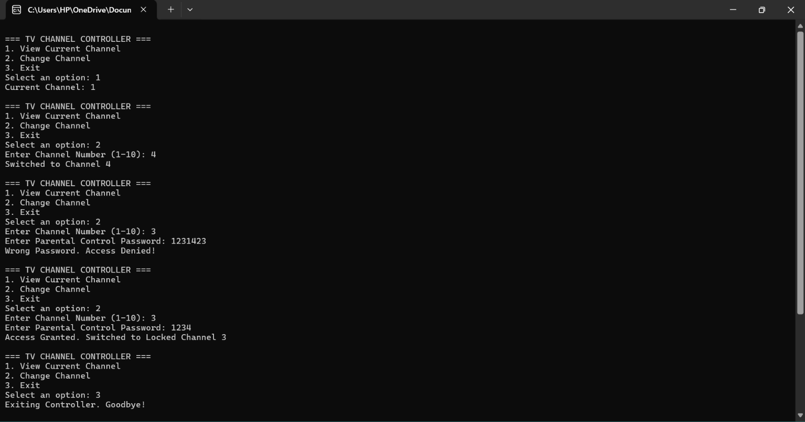

WEEK 6: FINALIZATION, DOCUMENTATION, AND DEMONSTRATION

Overview:
The final week involved polishing the project, preparing documentation, and presenting the fully functional prototype.

Key Learning Areas:
- Embedded project documentation and commenting standards

- User manual preparation

- Demonstration techniques for showcasing features

Practical Tasks:
  - Created complete user and developer documentation

  - Built a final demo board/prototype with all functionalities

  - Presented system workflow, code explanation, and feature highlights

  - Added future enhancement suggestions like app-based control.

Skills Developed:
  - Technical documentation and user guide writing

  - Embedded project demonstration skills

  - Presentation of embedded features to technical and non-technical audiences.

CHAPTER 5

CONCLUSION

My internship at Suresoft Systems Pvt Ltd has been an invaluable and transformative phase in my academic and professional journey. Specializing in embedded system software development, this experience provided me with a comprehensive understanding of how embedded technologies are applied in real-world industrial settings. From working closely with microcontroller architectures to writing and optimizing Embedded C code, I gained hands-on experience in creating software solutions that interact directly with hardware components, which has greatly enhanced my technical depth.
One of the key highlights of this internship was the opportunity to contribute to a project involving the decoding of IR signals and implementing control logic through interrupt-driven routines. I learned how to configure and use hardware timers, set up UART communication for real- time feedback, and structure embedded applications using modular design principles. This experience taught me the importance of system reliability, resource management, and timing precision, which are vital in embedded environments.
Furthermore, the structured project execution process at Suresoft—starting from requirement analysis and firmware development to simulation and testing—helped me understand the complete lifecycle of an embedded software project. Tools such as Keil for programming and Proteus for simulation provided practical exposure to the development and debugging processes typically used in professional embedded system design.
Equally important was the professional exposure to collaborative development. I participated in team discussions, code reviews, and milestone evaluations that helped me improve not only my technical capabilities but also my ability to communicate and justify design decisions effectively. I gained an appreciation for coding standards, documentation practices, and maintaining version- controlled repositories, all of which are essential for maintaining consistency and clarity in team- based development environments.

This internship also reinforced the importance of testing and validation in embedded systems, especially for applications in consumer electronics and safety-critical domains. I learned to design robust code that could handle real-time constraints and hardware uncertainties, and to build systems that are both scalable and maintainable.
Overall, this internship at Suresoft Systems Pvt Ltd has solidified my interest in embedded systems and laid a strong foundation for my future career in this domain. It allowed me to bridge the gap between academic learning and industrial application, while cultivating a problem-solving mindset and a strong technical skill set. As I move forward, I carry with me not just technical knowledge, but also the confidence and adaptability required to thrive in the fast-evolving field of embedded software development.

